**Desktop Project Report**

**Name:** Deepak kumar Submitted to: Mr. Jitender sir

**UID:** 23BCA10752

**Section:** BCA-3(B)

**Subject:** Desktop Publishing Lab

# Project Title

**Making Banner Using Adobe Photoshop**

**Project Title:** Creating Banner for Food Restaurants Using Adobe Photoshop.

**Technologies Used:** Adobe Photoshop Application **Drive Link:**

1. Abstract
2. Procedure
3. Project Objectives
4. Technologies Implemented
5. Project Features
6. Conclusion

# Desktop Publishing Project -01

Creating Banner for Food Restaurants Using Adobe Photoshop

## Introduction :-

In this mini project, I am designing a banner for a food restaurant using Adobe Photoshop, a widely used graphic design tool. The main goal is to create a visually appealing and professional-looking banner that promotes the restaurant’s menu and services effectively. This banner will include attractive images of food, bold text for key information, and a color scheme that suits the restaurant's theme. By using Photoshop features like layers, text styles, and filters, I aim to make the design eye-catching and clear. This project will help me understand how design plays an important role in marketing, and how good visuals can attract more customers to a business.

## Objective :-

The main objective of this project is to create an attractive and professional banner for a food restaurant using Adobe Photoshop. The banner should highlight the restaurant’s food, services, and special offers in a way that catches people's attention. By using design elements like images, text, and colors, the goal is to make a banner that helps promote the restaurant and attract more customers. This project also aims to improve my skills in Photoshop and learn how to create effective marketing designs.

## Concept Used :-

The concept of this project is to create a visually appealing banner for a food restaurant using design elements like images, text, and colors. The banner will showcase the restaurant’s food and special offers in a way that grabs attention. By using Photoshop tools like layers and text effects, the design will look professional and help the restaurant attract more customers.

## Abstract :-

This project is about designing a banner for a food restaurant using Adobe Photoshop. The goal is to create a banner that looks attractive and helps promote the restaurant’s food and services. Using Photoshop tools, the banner will include images, text, and colors that make it stand out. The design will follow basic rules like balance, color contrast, and clear text to make it eye-catching and professional. This project helps in learning how to use Photoshop and how design can be used to promote a business effectively.

## Procedure :-

Steps to Create a Professional Restaurant Banner in Adobe Photoshop :-

1. **Set Up Your Document:**

Open Photoshop and click on File > New.

Set the dimensions of your banner depending on where you plan to use it (e.g., 1200 x 600 pixels for web banners or a larger size for print).

Choose a resolution of 72 dpi for web or 300 dpi for print. Set the background to transparent or white, depending on your preference.

1. **Choose a Color Scheme:**

Pick a color scheme that fits the restaurant’s theme. For example, use warm colors like red, orange, or yellow for a fast-food vibe, or cool colors for a more elegant restaurant.

Use the Color Picker Tool (G) to select your main colors.

1. **Add a Background Image or Color:**

If you want to use an image for the background, go to File > Place Embedded and insert a high-quality image.

Adjust the size and position of the image by using Ctrl + T (Transform Tool).

If you want a simple background color, use the Paint Bucket Tool (G) or apply a gradient using the Gradient Tool (G).

1. **Place Images of Food:**

Add high-quality images of dishes the restaurant offers by using File > Place Embedded.

Use Ctrl + T to resize and position the images on the banner. Ensure they are prominent and attract attention.

Apply Layer Masks to blend images smoothly into the background.

1. **Add Text:**

Use the Text Tool (T) to add important information such as the restaurant’s name, tagline, or special offers (e.g., "20% Off", "New Menu Items").

Choose fonts that match the restaurant's style—bold fonts for fast food, elegant fonts for fine dining.

Make key information, like discounts or special offers, larger and more noticeable.

1. **Use Layer Effects for Text:**

Add effects to your text by right-clicking on the text layer and choosing Blending Options.

Apply Drop Shadow or Stroke to make the text stand out more. You can also experiment with Gradient Overlays or Bevel & Emboss to give the text more depth.

1. **Add Logos and Social Media Icons:**

Place the restaurant’s logo on the banner by using File > Place Embedded.

Add small icons for social media (Facebook, Instagram, etc.) near the bottom to encourage engagement.

Make sure these elements don’t dominate the design but are clearly visible.

1. **Organize with Layer Groups:**

Organize different elements (text, images, background) into groups. Select the layers you want to group, right-click, and choose Group from Layers.

This helps keep your workspace tidy and easier to manage.

1. **Final Touches:**

Use Adjustment Layers (brightness/contrast, color balance) to enhance the overall look.

Make sure the text is readable and the design is not too cluttered. Zoom out to see how the banner looks overall and make any final adjustments.

1. **Save Your Banner:**

Save your work in .PSD format to keep all the layers for future editing.

To export for web or print, go to File > Export > Export As and choose JPEG or PNG. For print, select PDF.

## Images :-

**Step 1 :-**

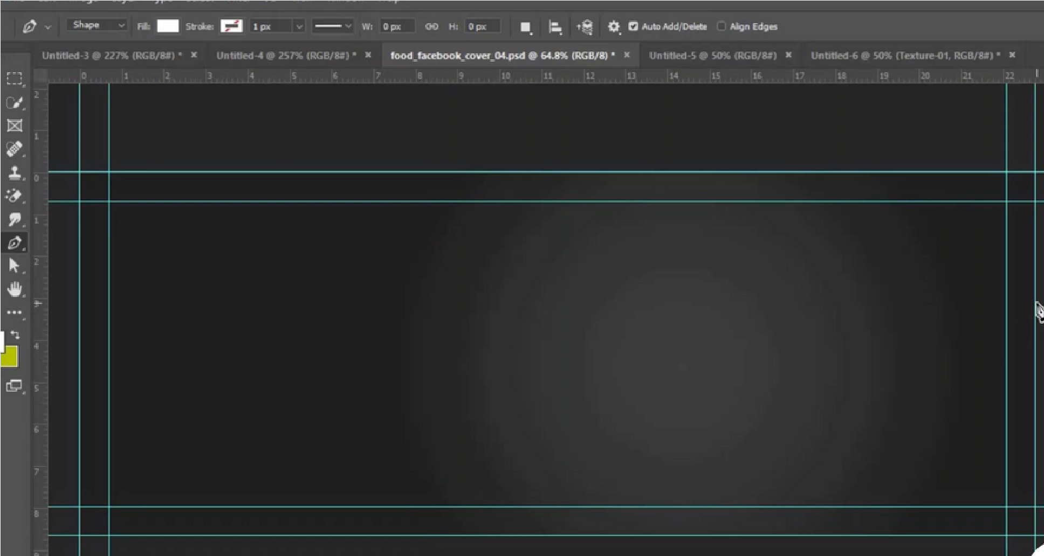

### Step 2 :-

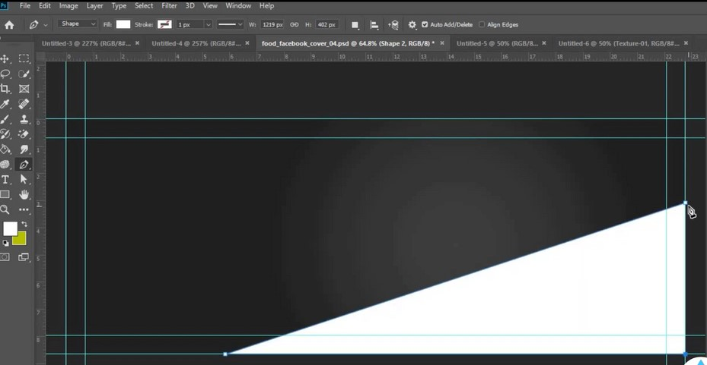

### Step 3 :-

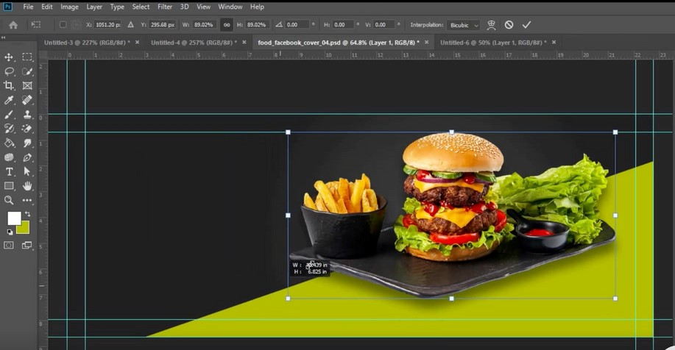

### Step 4 :-

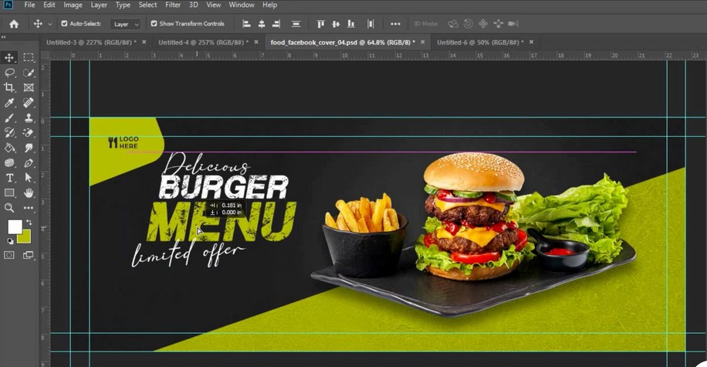

### Step 5 :-



### Step 6 :-

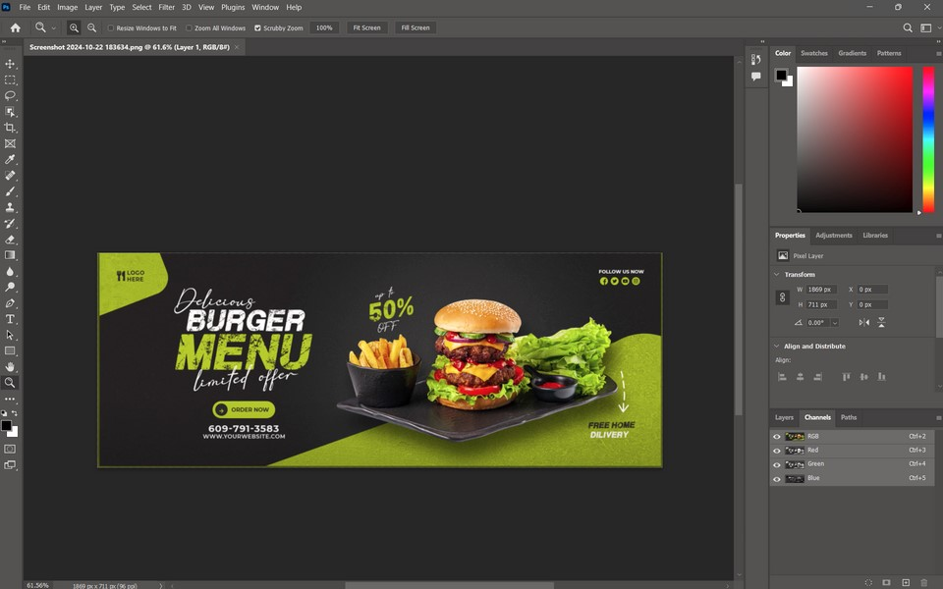

**Final Output 1**

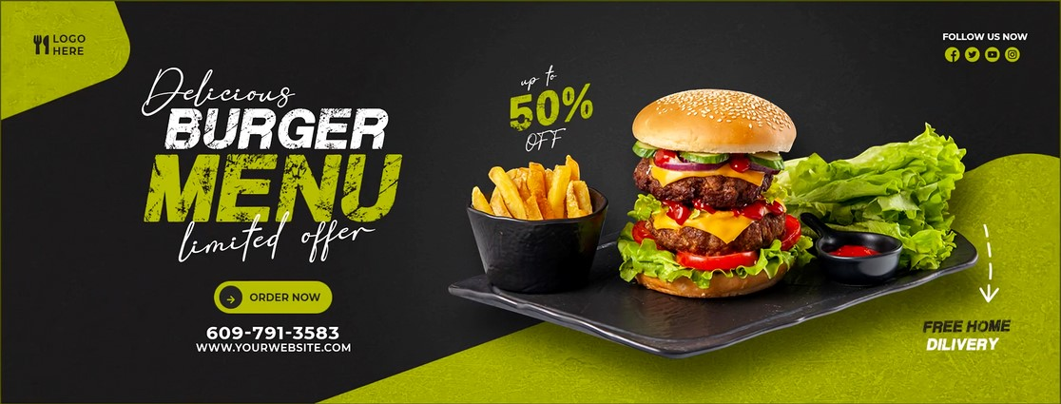

**Final Output 2**

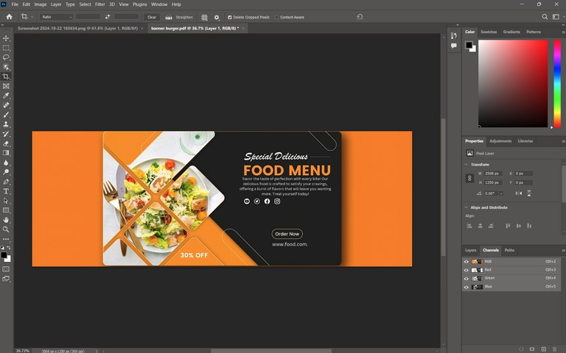

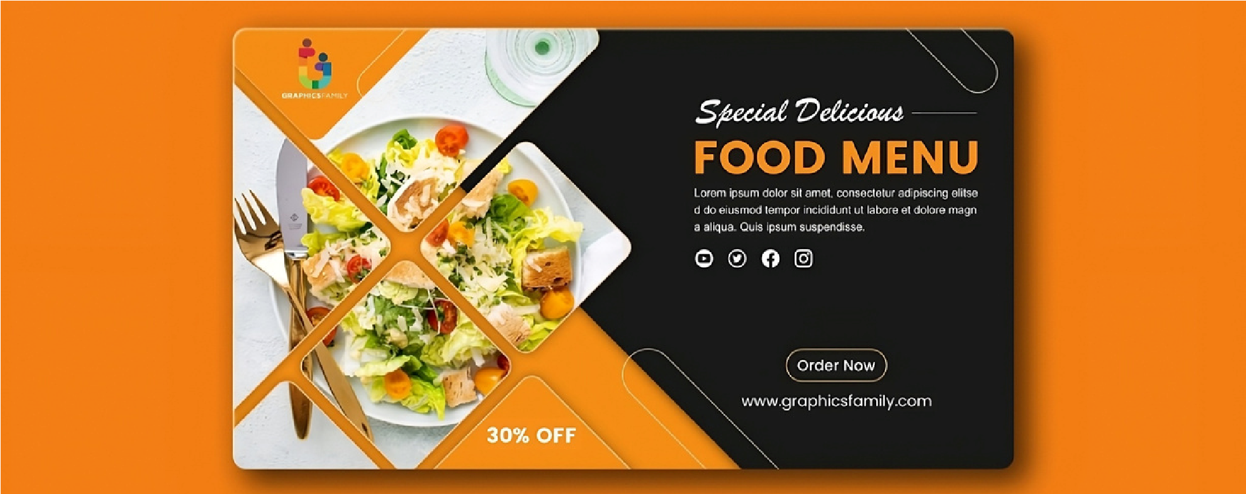

**Project Objectives:**

1.To design an attractive banner that promotes the restaurant’s food and services.

2.To use Adobe Photoshop tools to create a professional-looking design.

3.To include high-quality images, easy-to-read text, and a color scheme that fits the restaurant’s theme.

4.To highlight important information, like special offers or discounts, clearly.

5.To improve my skills in graphic design by using basic design principles like balance and contrast.

6.To make a banner that can be used both online and for printing.

**Technologies Implemented:**

1.**Adobe Photoshop 2023:** Used as the main software for designing the banner, with tools like layers, text effects, and image adjustments.

2.**Layers and Masks:** Used to organize different elements (images, text, background) and blend them smoothly into the design.

3.**Typography Tools:** Used to add and style text, making key information like the restaurant’s name and special offers stand out.

4.**Image Editing Tools:** Used to enhance food images, adjust brightness and contrast, and make the banner visually appealing.

5.**Export Options:** Used to save the banner in formats like JPEG or PNG for digital use and PDF for printing.

**Project Features:**

1.**High-Quality Images:** The banner includes clear, attractive food images to grab attention.

2.**Eye-Catching Design:** The use of bright colors, bold text, and balanced layout makes the banner stand out.

3.**Professional Text Styling:** Important details like the restaurant’s name and special offers are highlighted with stylish fonts and effects.

4.**Clear Information:** Key messages, such as discounts and promotions, are easy to read and understand.

5.**Multi-Platform Usability:** The banner is designed to be used both online (websites, social media) and for print (flyers, posters).

### Conclusion

This project successfully demonstrates the creation of a professional restaurant banner using Adobe Photoshop, combining visual appeal with effective communication of key information. The design integrates high-resolution images, strategic use of typography, and a well-coordinated color scheme to reflect the restaurant's brand identity. Through the application of essential design principles such as contrast, balance, and hierarchy, the banner effectively highlights the restaurant’s special offers and services while maintaining clarity and aesthetic appeal.

The project also showcases the flexibility of Adobe Photoshop in designing materials for both digital and print platforms, ensuring the banner is adaptable for various marketing needs. Overall, this project has provided valuable insights into the process of designing marketing assets, enhancing practical skills in graphic design, and preparing for real-world applications in the field of digital advertising.